Dear Valued Resident.

We are required to provide you with certain documents that provide information about your rights, responsibilities and protections. All household members should review these documents.

We are providing these documents in an electronic format. Printed versions of these documents are available in the management office. If you need assistance, please contact the property management staff by phone or email.

(Note from RBD: If you have multiple properties, you should edit this list as you see fit. If you have set up a central email and phone number, provide that information):
Manager One Phone: xxx-xxx-xxxx Email: manager@propert1.com
Manager Two Phone: xxx-xxx-xxxx Email: manager@property2.com
Manager Three Phone: xxx-xxx-xxxx Email: manager@property3.com

The Head-of-household, co-head-of-household and all adult household members must sign the 9887 (page 4). Multiple people can sign this form.

The Head-of-household, co-head-of-household and all adult household members must sign the 9887A (page 7). Each household member must sign an individual copy of this form.

If you would like to change or update information about any person we should contact to assist you, please complete HUD Form 92006 (Page 8). If you do not want to update this information, you do not need to complete this form.

An adult household member (preferably the Head of Household) must sign the Acknowledgement of Receipt of these documents (Page 25).

Please return all signed forms to .

Note from RBD: You should specify where the resident should drop off required forms. If they can drop them off at the management office, that’s fine. If you have a Drop Box provide that information.

If you prefer, you may also scan copies of signed forms and provide them to us via xxxxxxxxxxx. Note from RBD: You should specify if there is an electronic method used to provide required forms. If you have a resident portal or access to a document transfer system, provide that information.

Please keep the originals. HUD requires that we maintain original copies in your tenant file. If you submit your forms electronically, we will contact you and let you know when we are ready to schedule an appointment to collect these forms.

If you don’t feel comfortable with either delivery option, please feel free to contact the property management staff and we will arrange an alternative.

We are doing everything we can to reduce any burden created by your requirement to recertify. If you have any questions or concerns, please don’t hesitate to email or call.

If you have difficulty understanding English, please request our assistance and we will ensure that you are provided with meaningful access based on your individual needs.

Si tiene dificultades para comprender el inglés, solicite nuestra ayuda y nos aseguraremos de que se le proporcione un acceso significativo en función de sus necesidades individuales. (Note from RBD – this Spanish translation was provided by a Microsoft translator tool. Be sure to verify with someone who speaks Spanish. If Spanish is not the alternative language described in your Language Assistance Plan, change this to comply with your LAP or add other languages.)

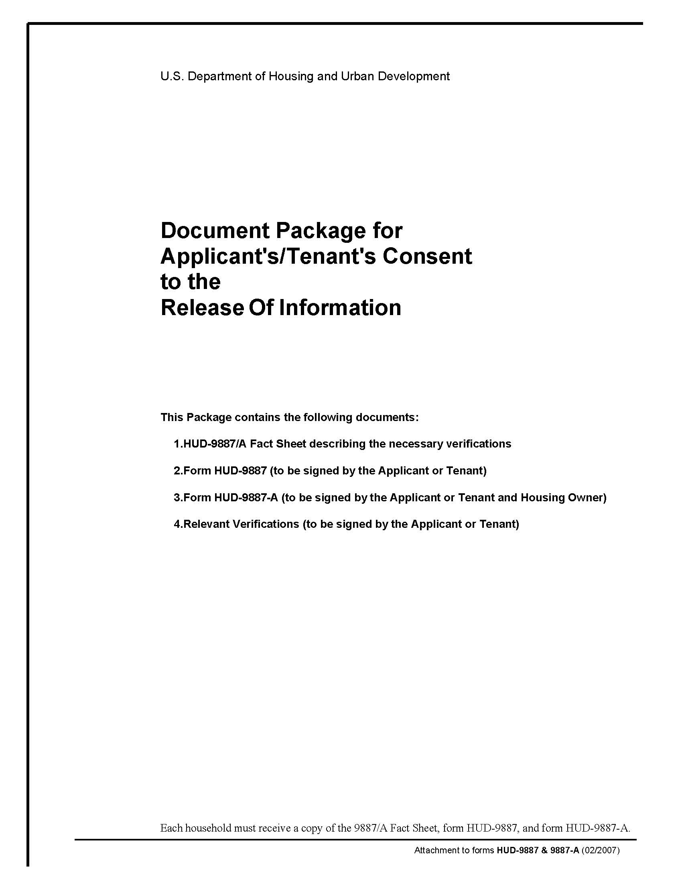
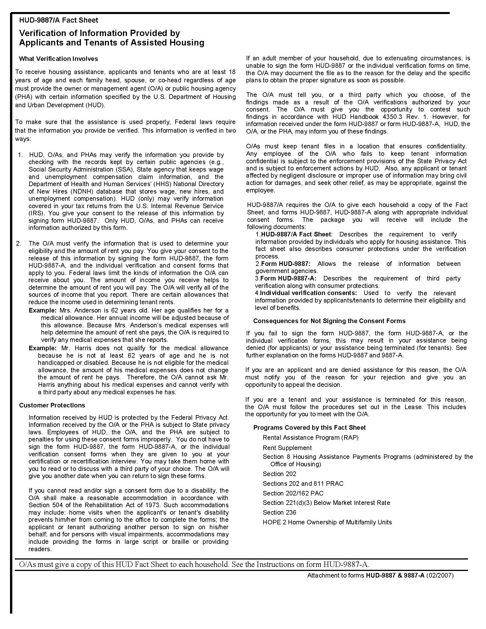
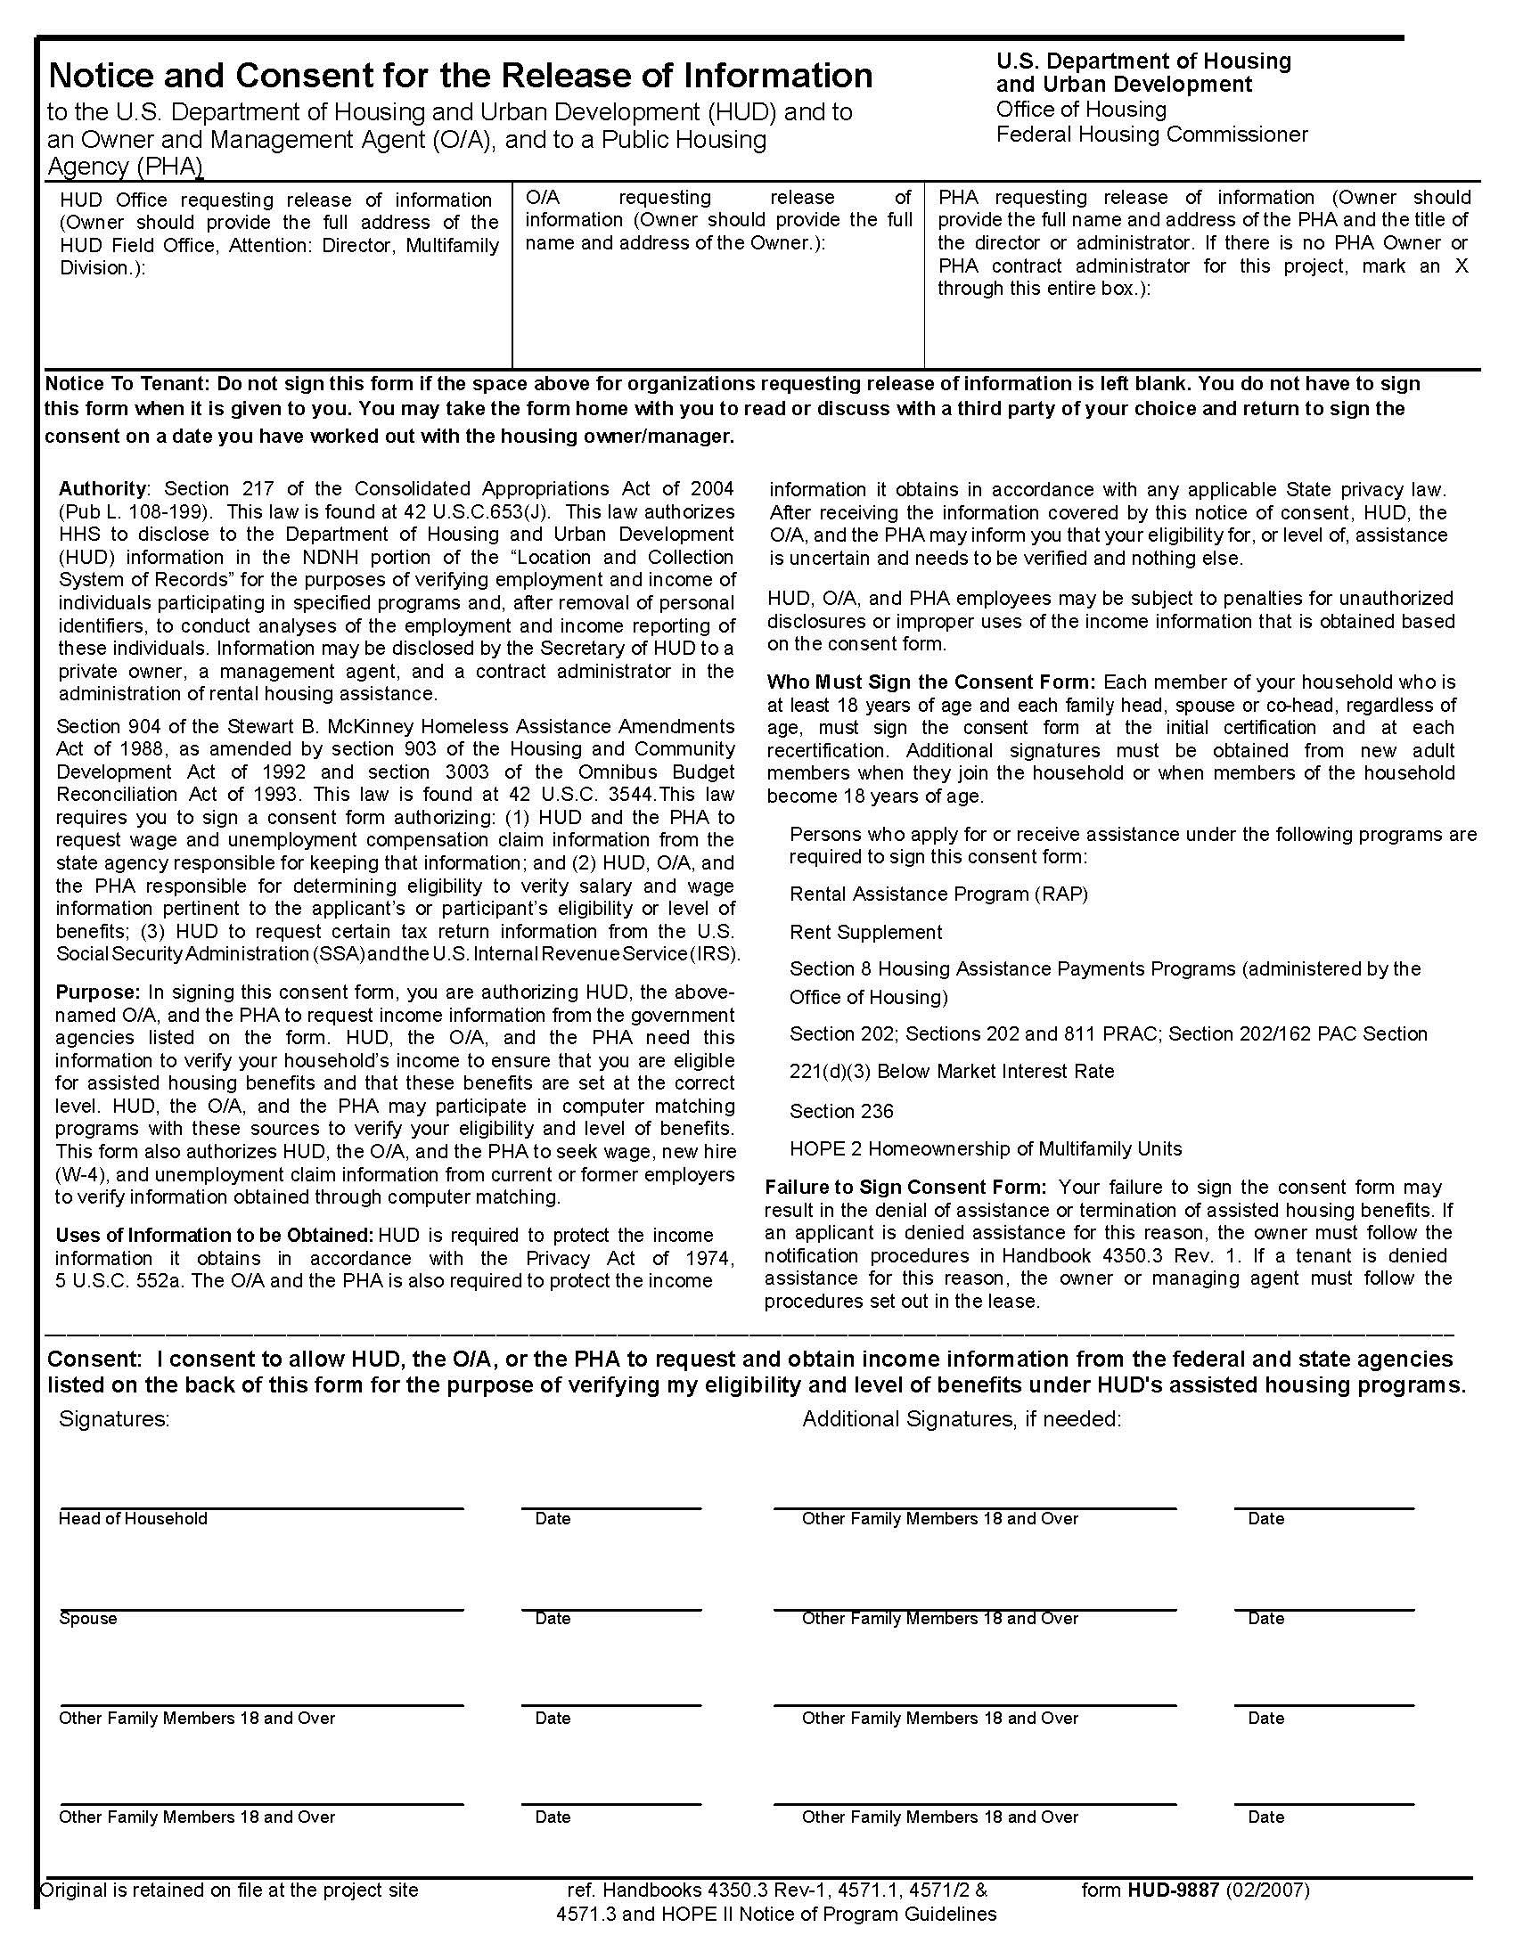
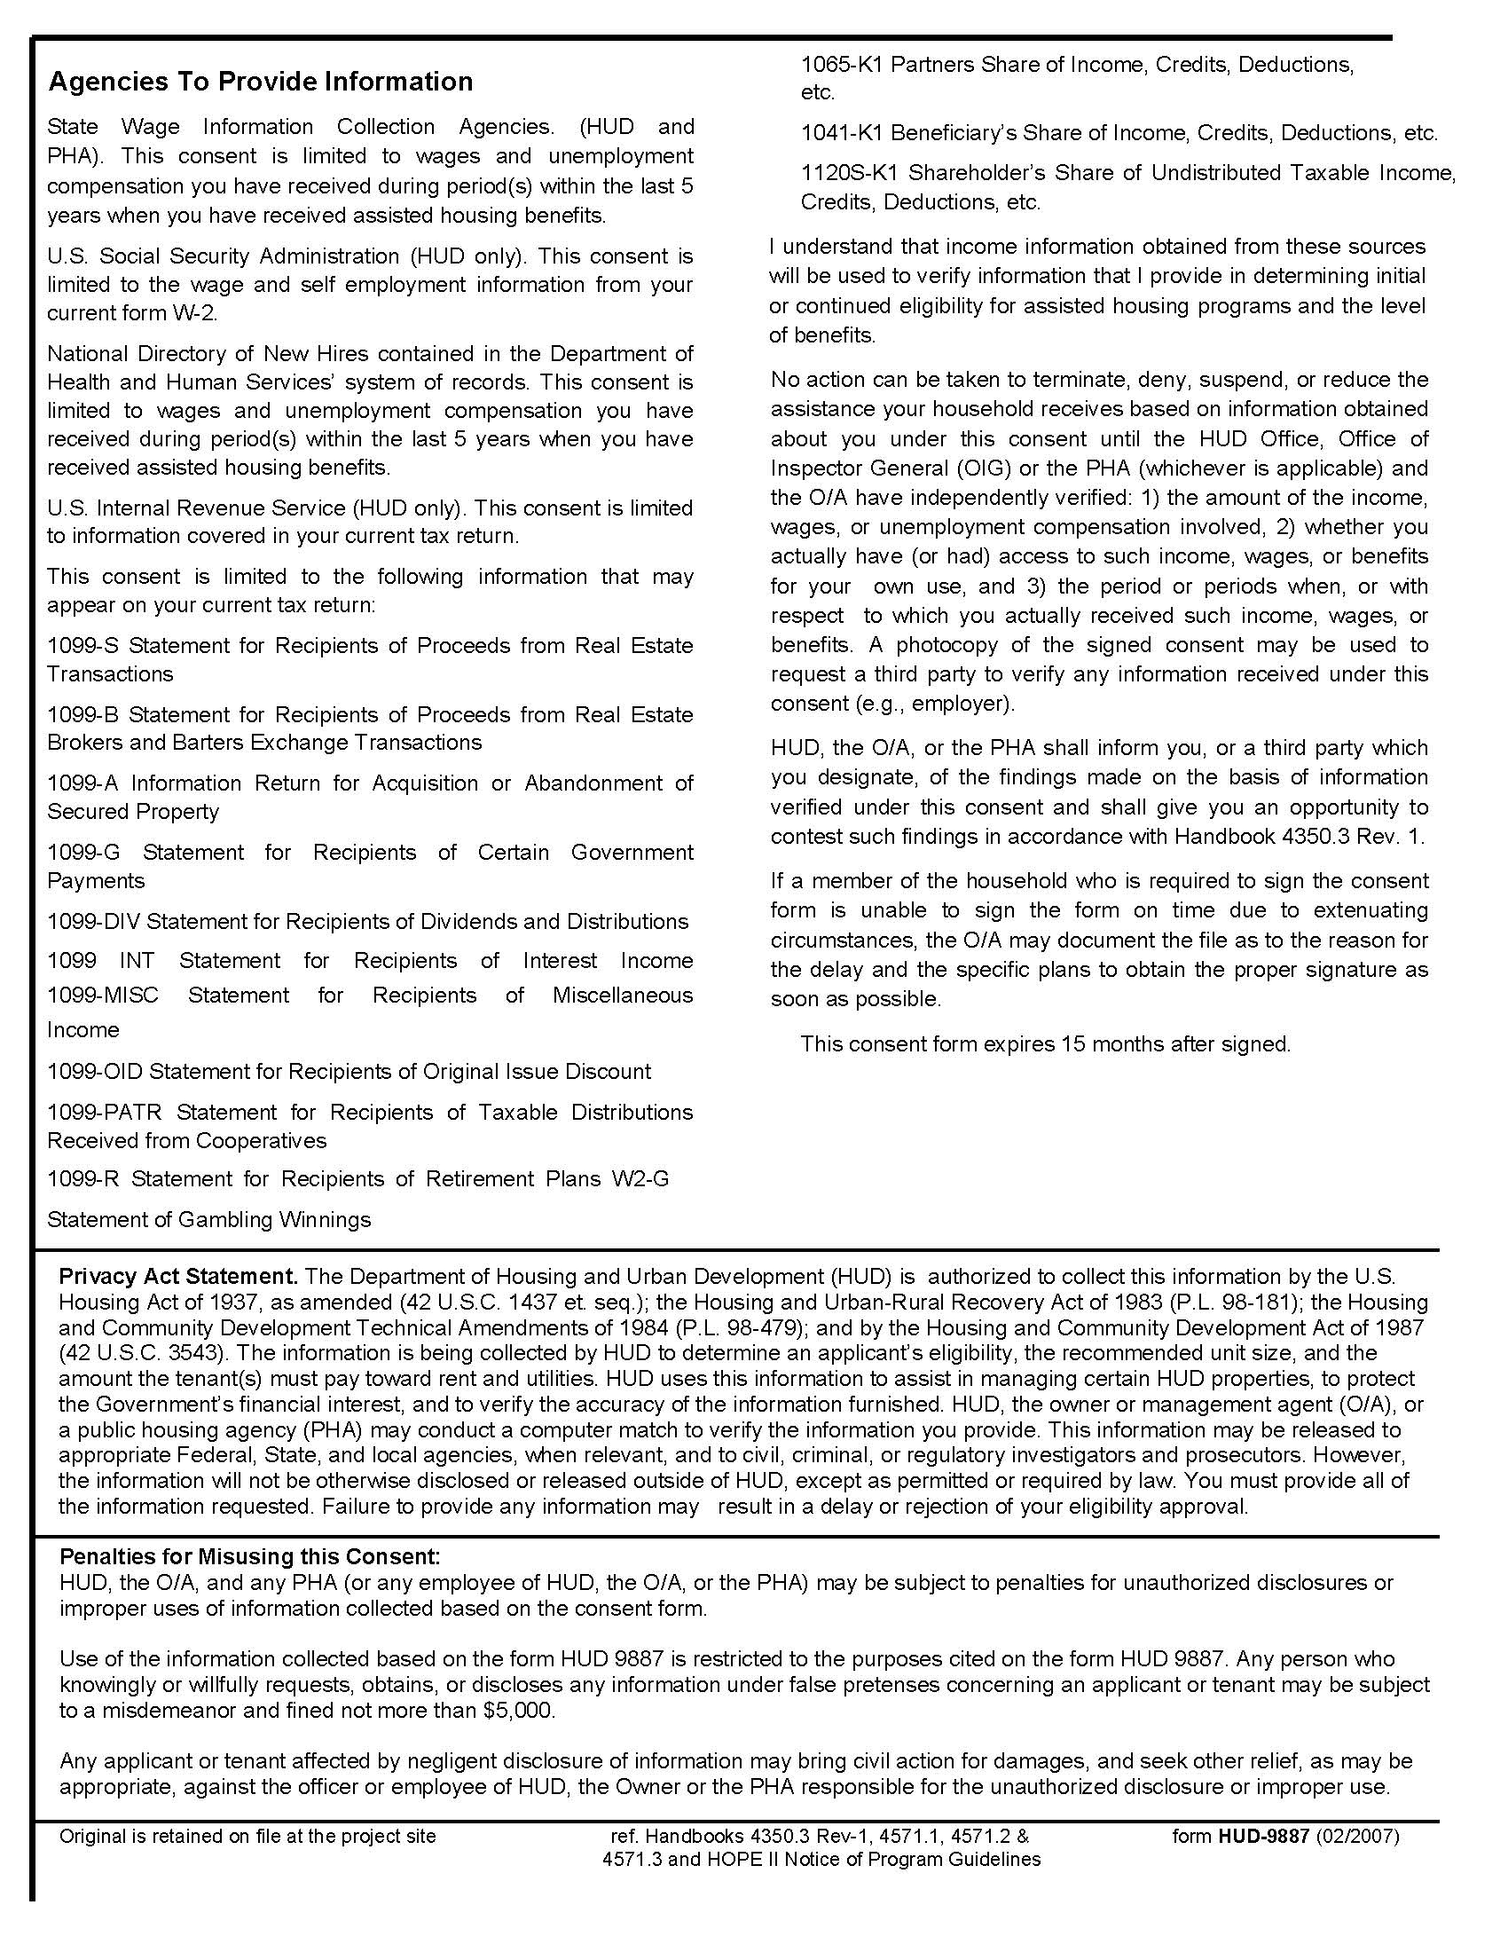
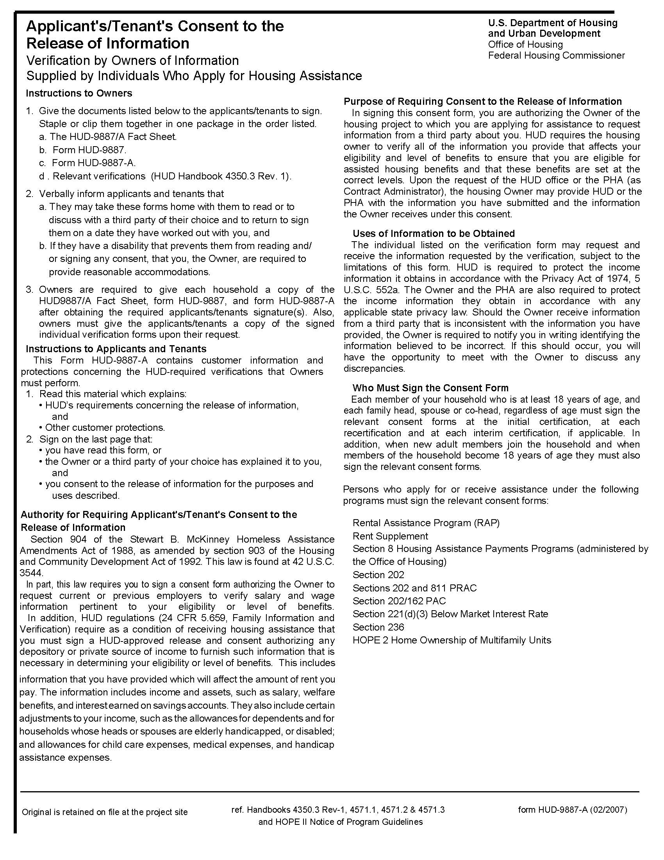
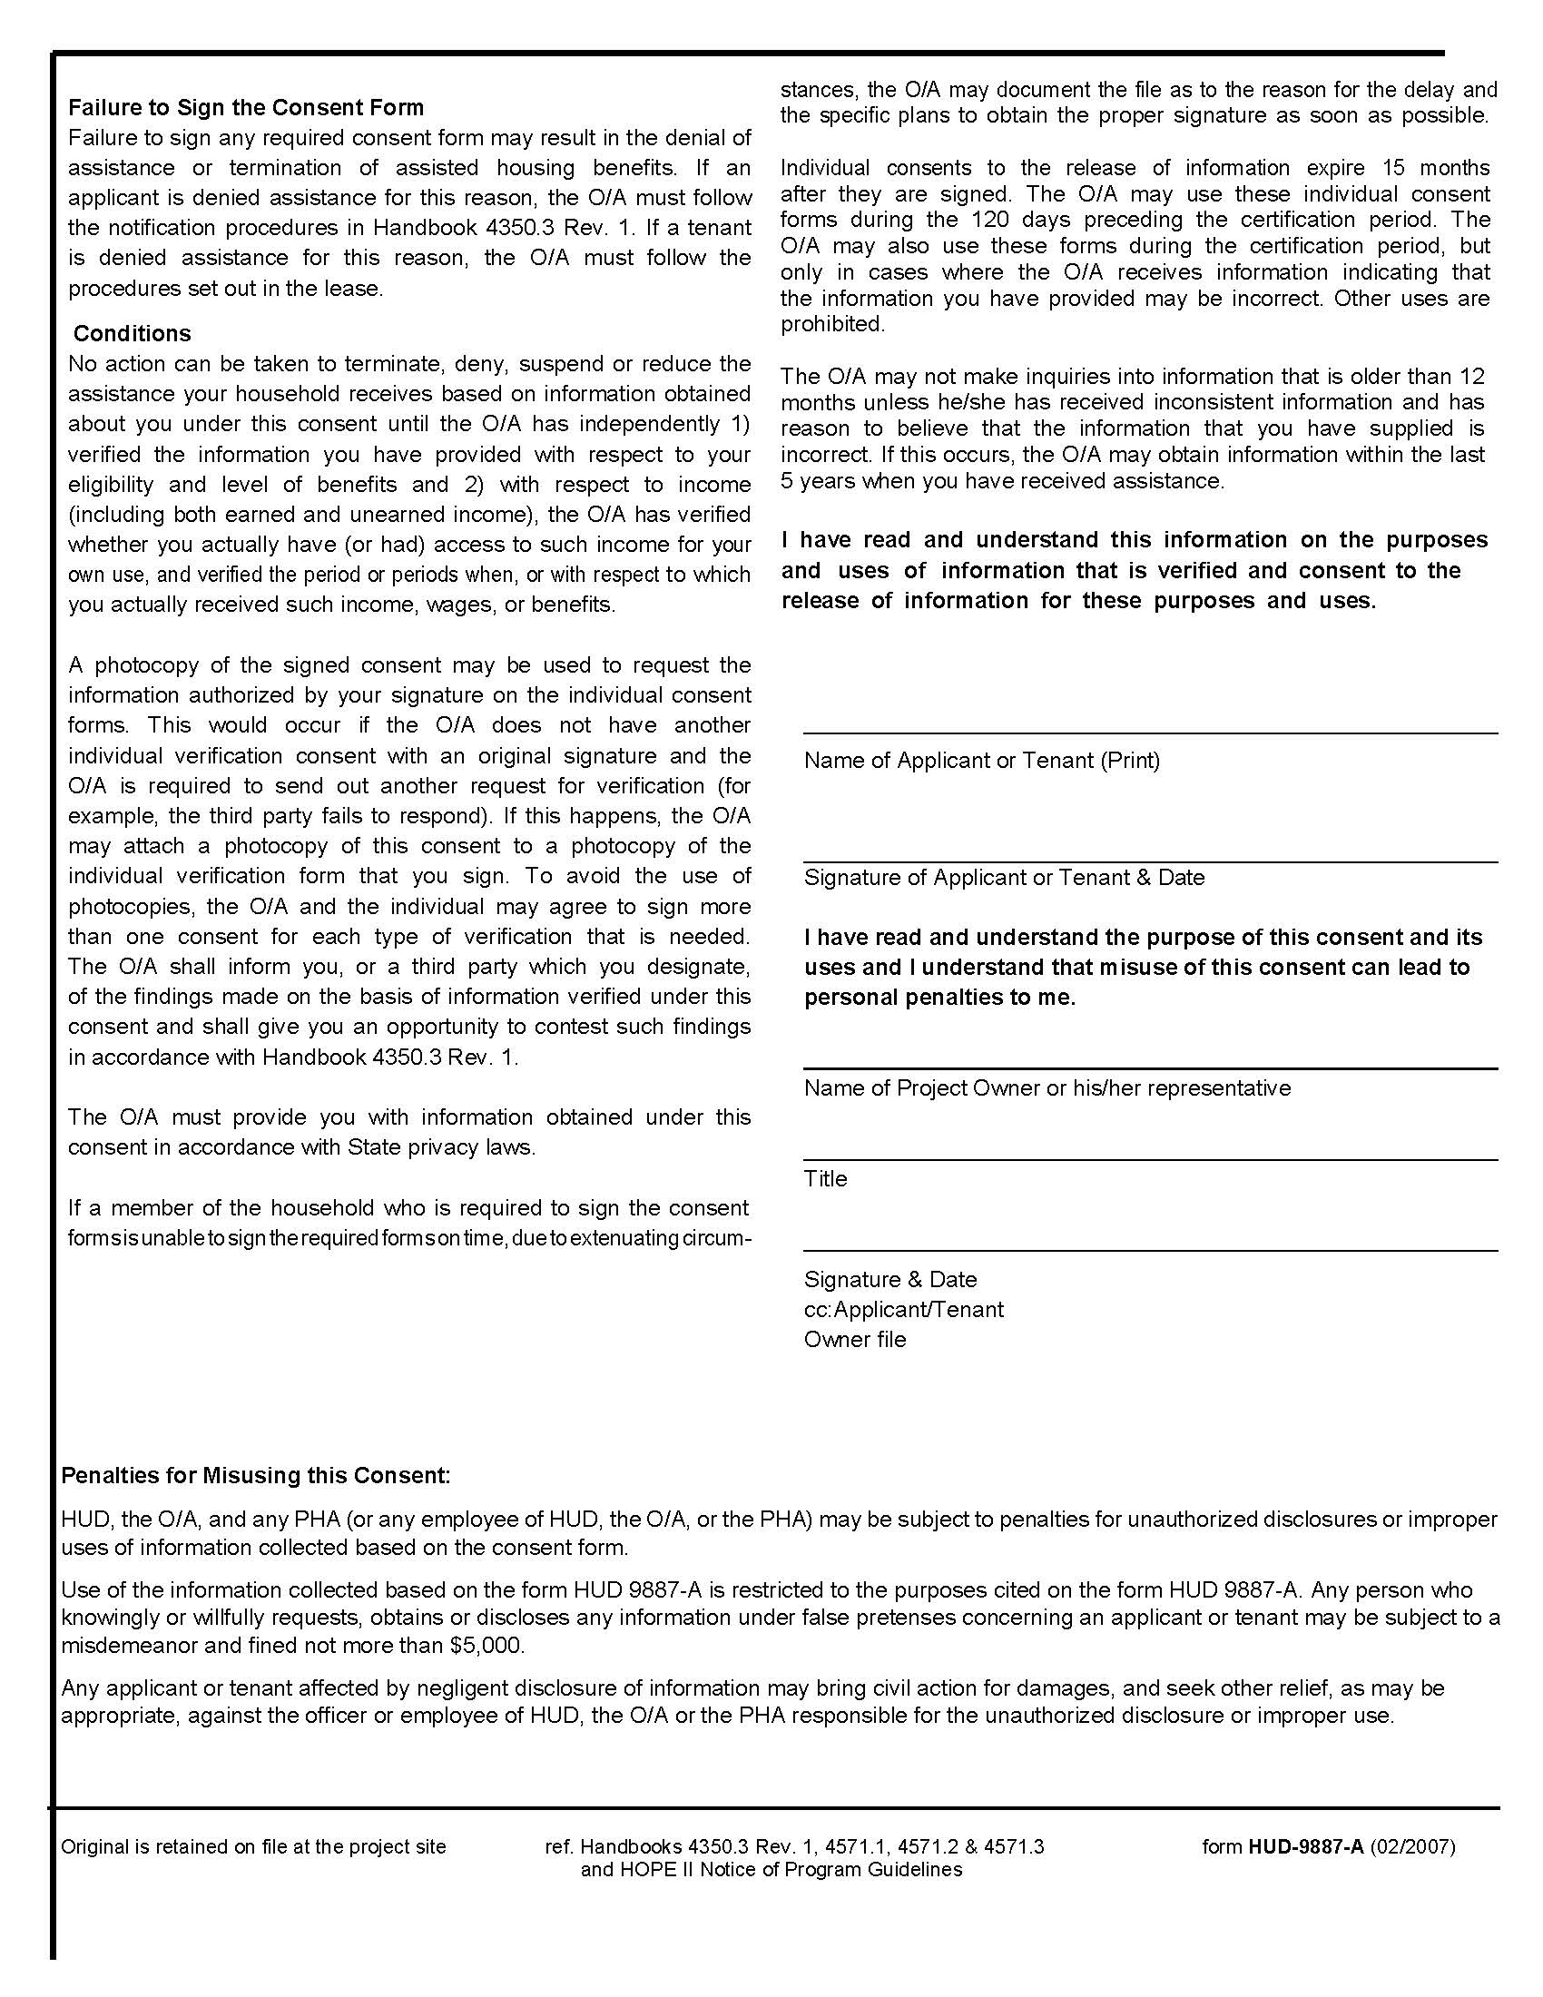
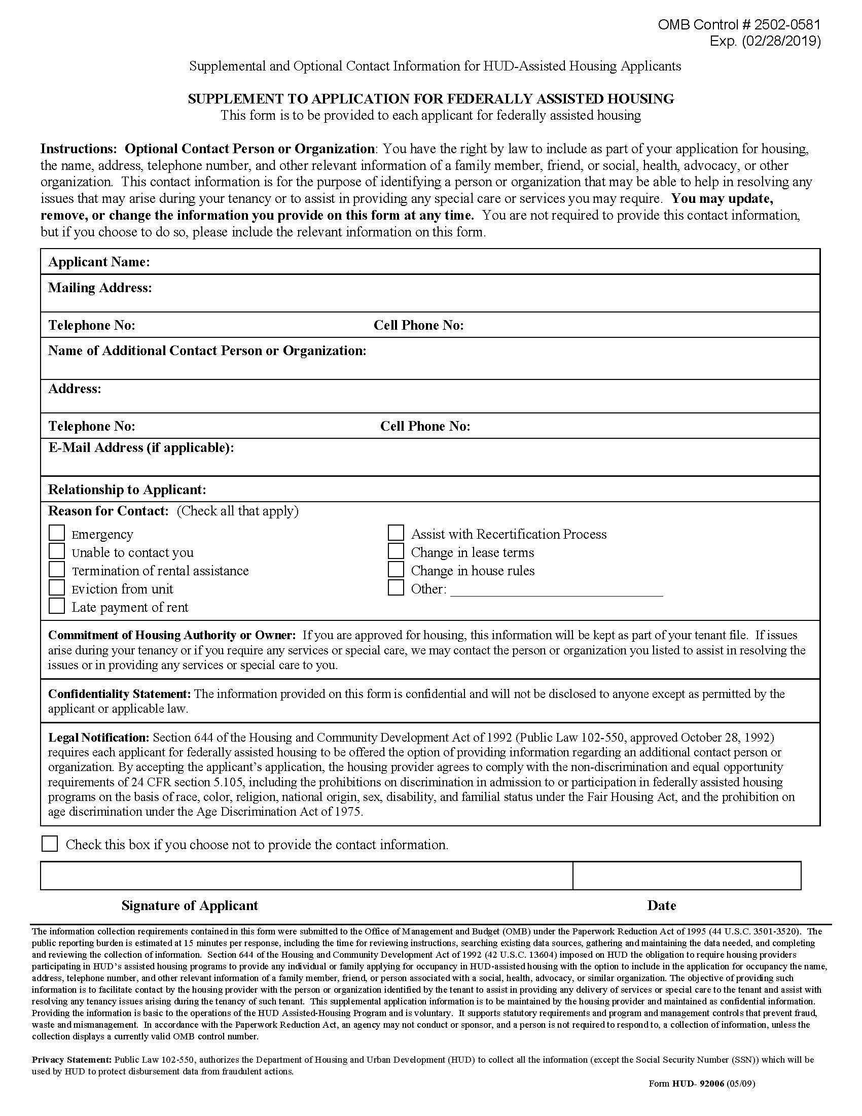
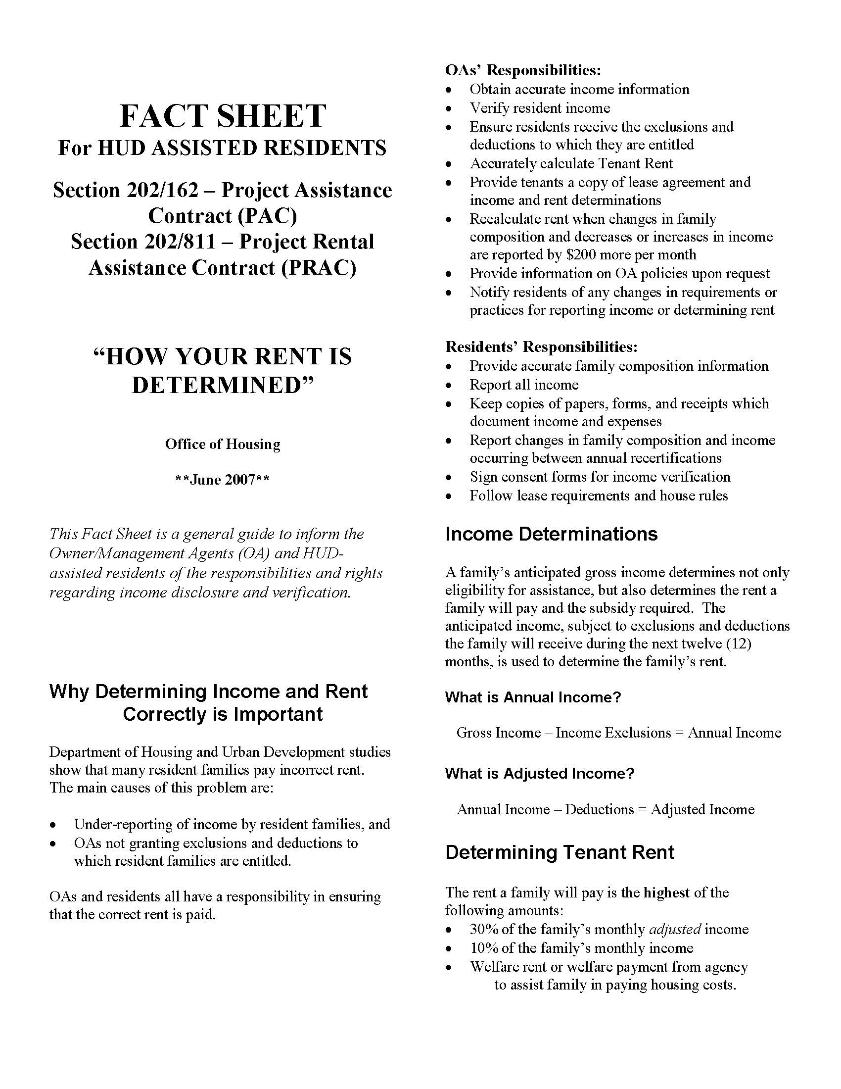
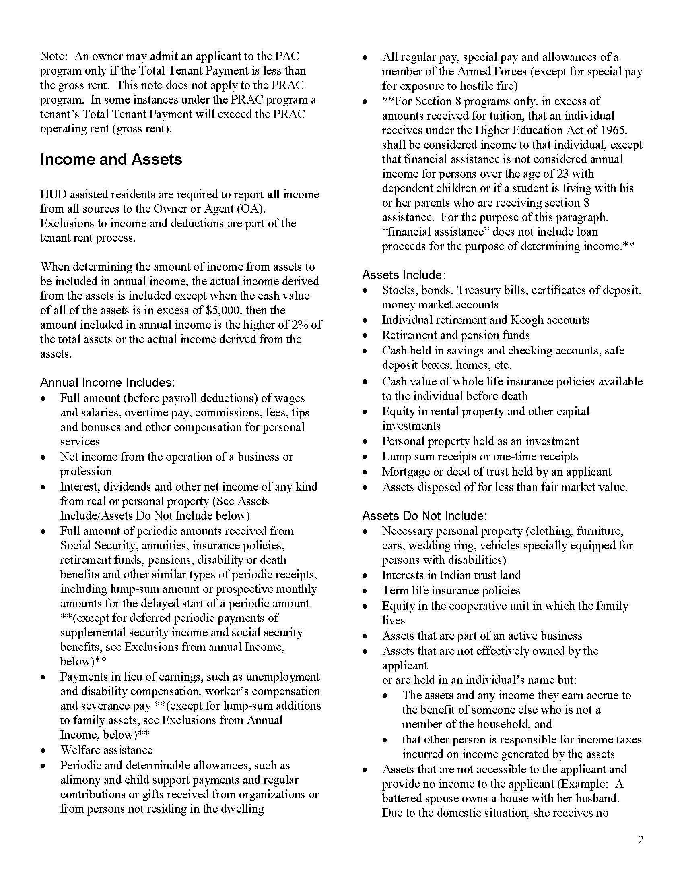
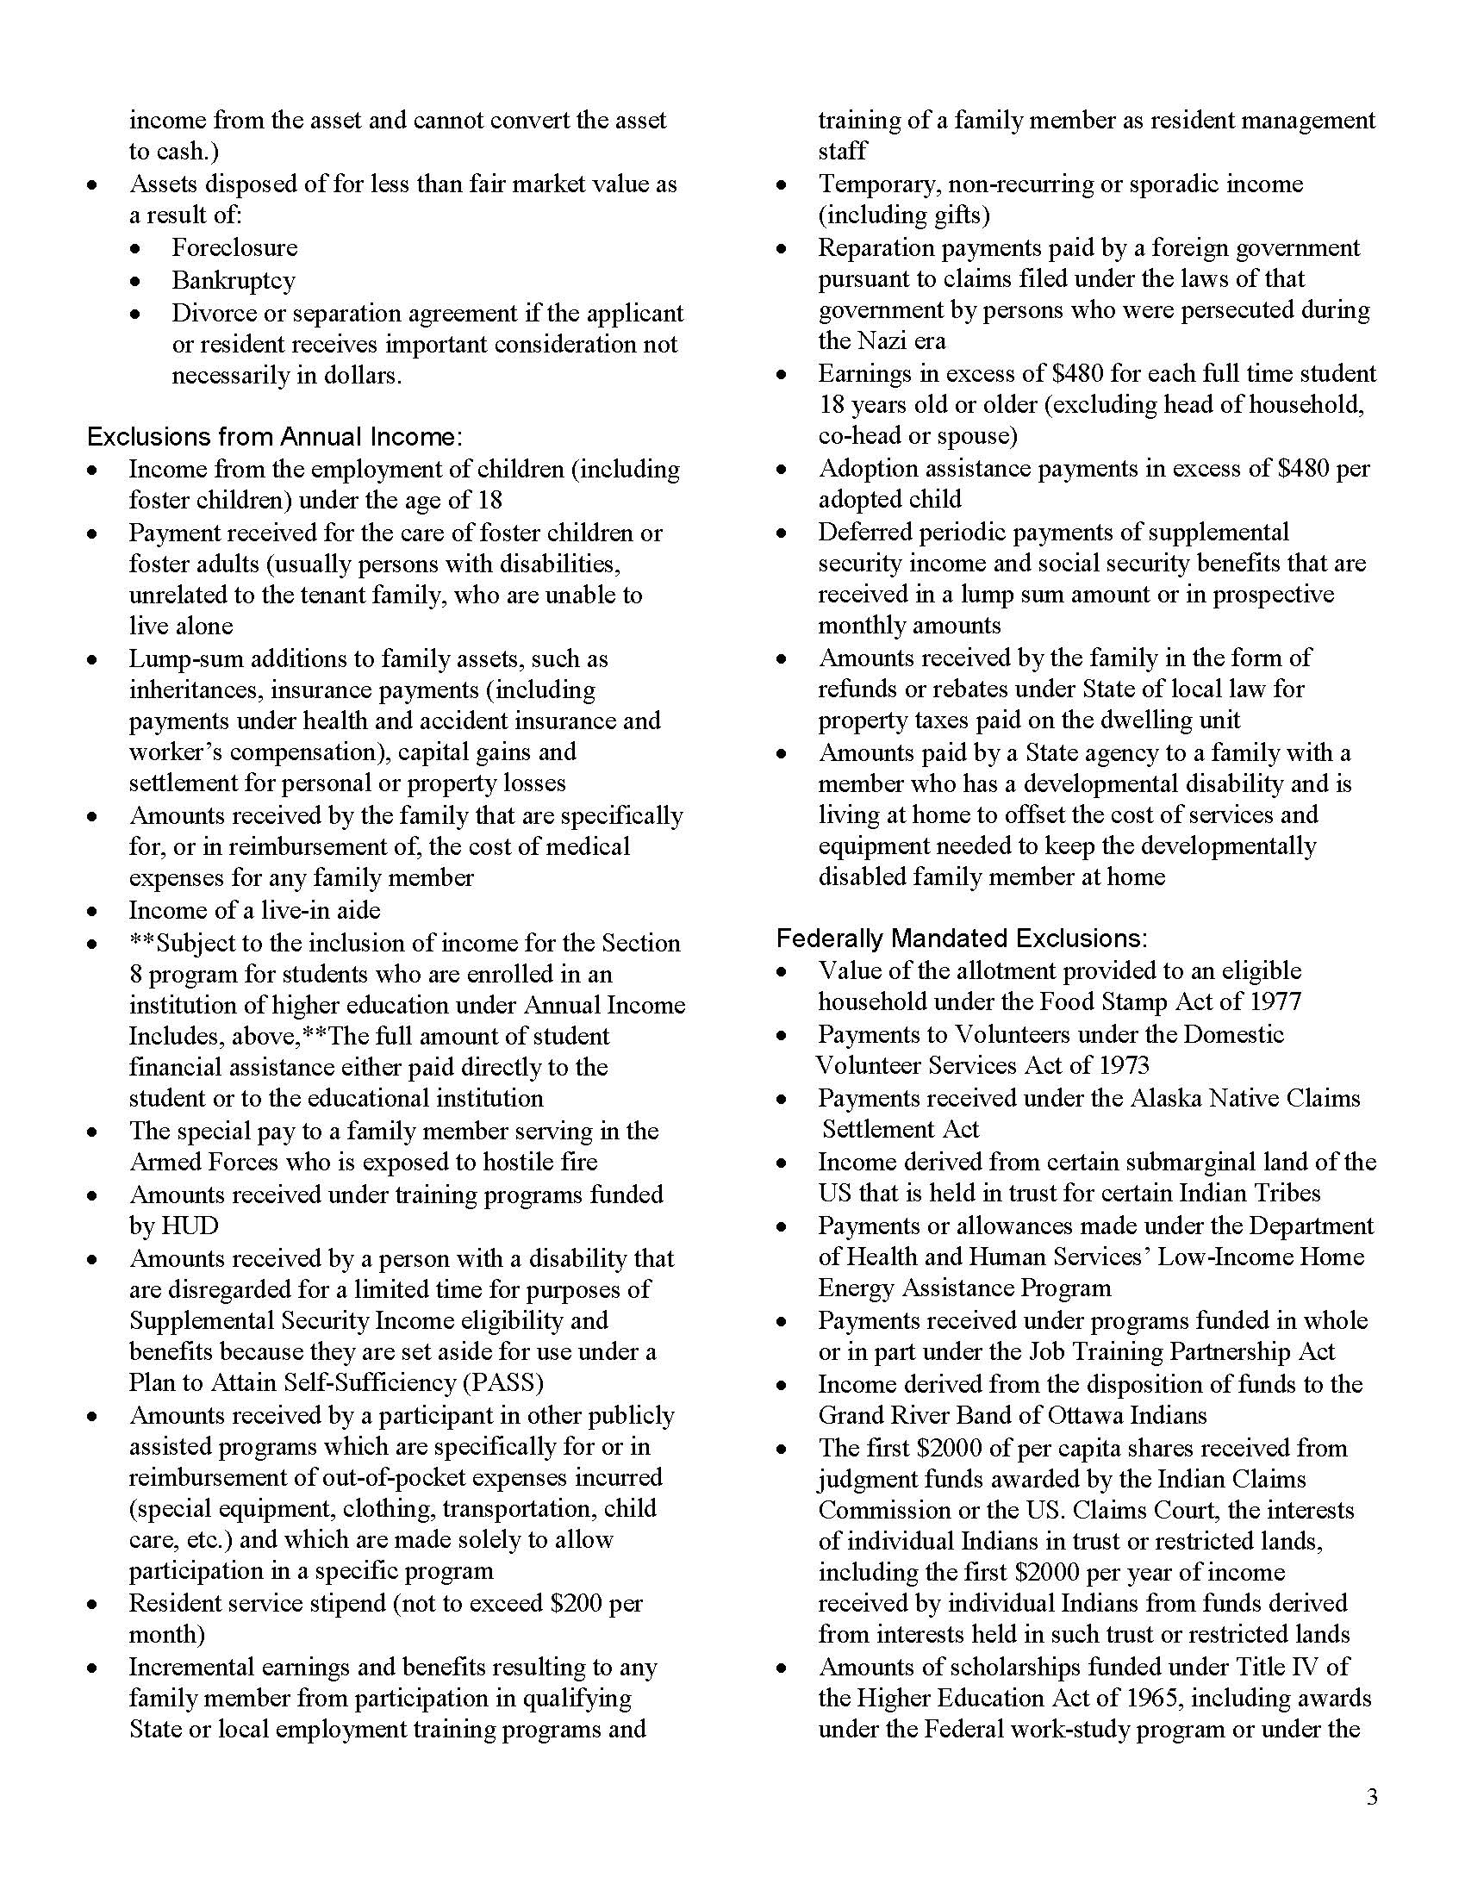
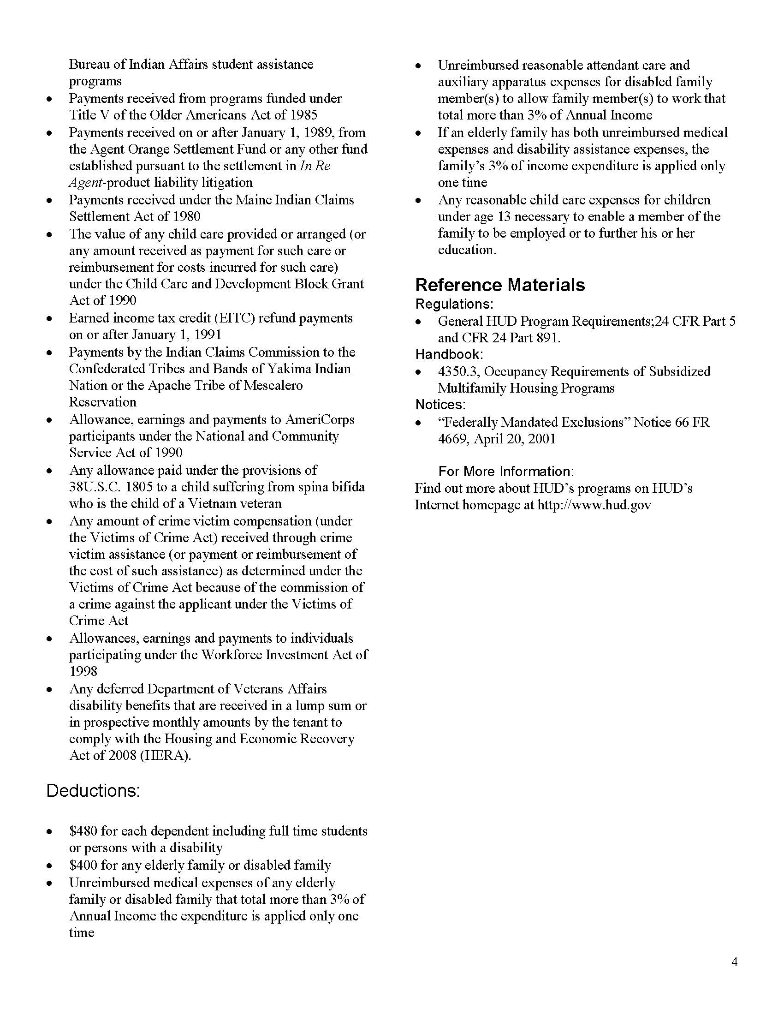

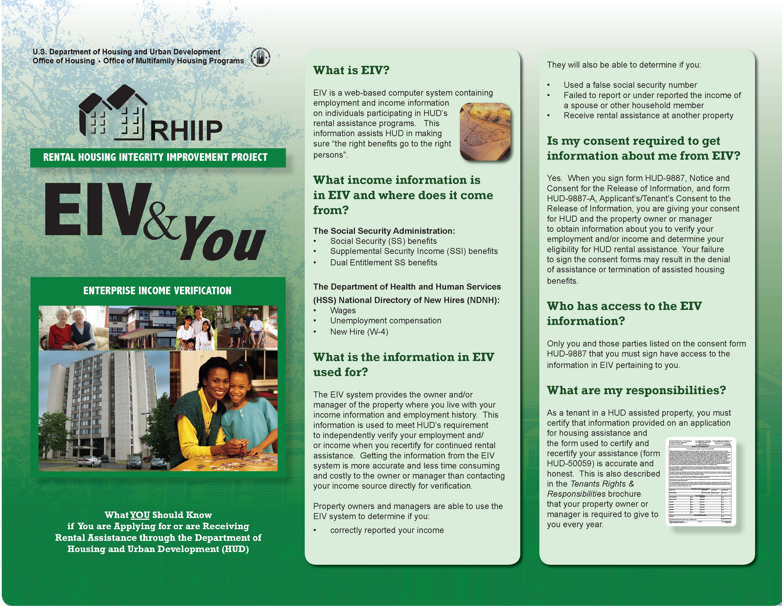
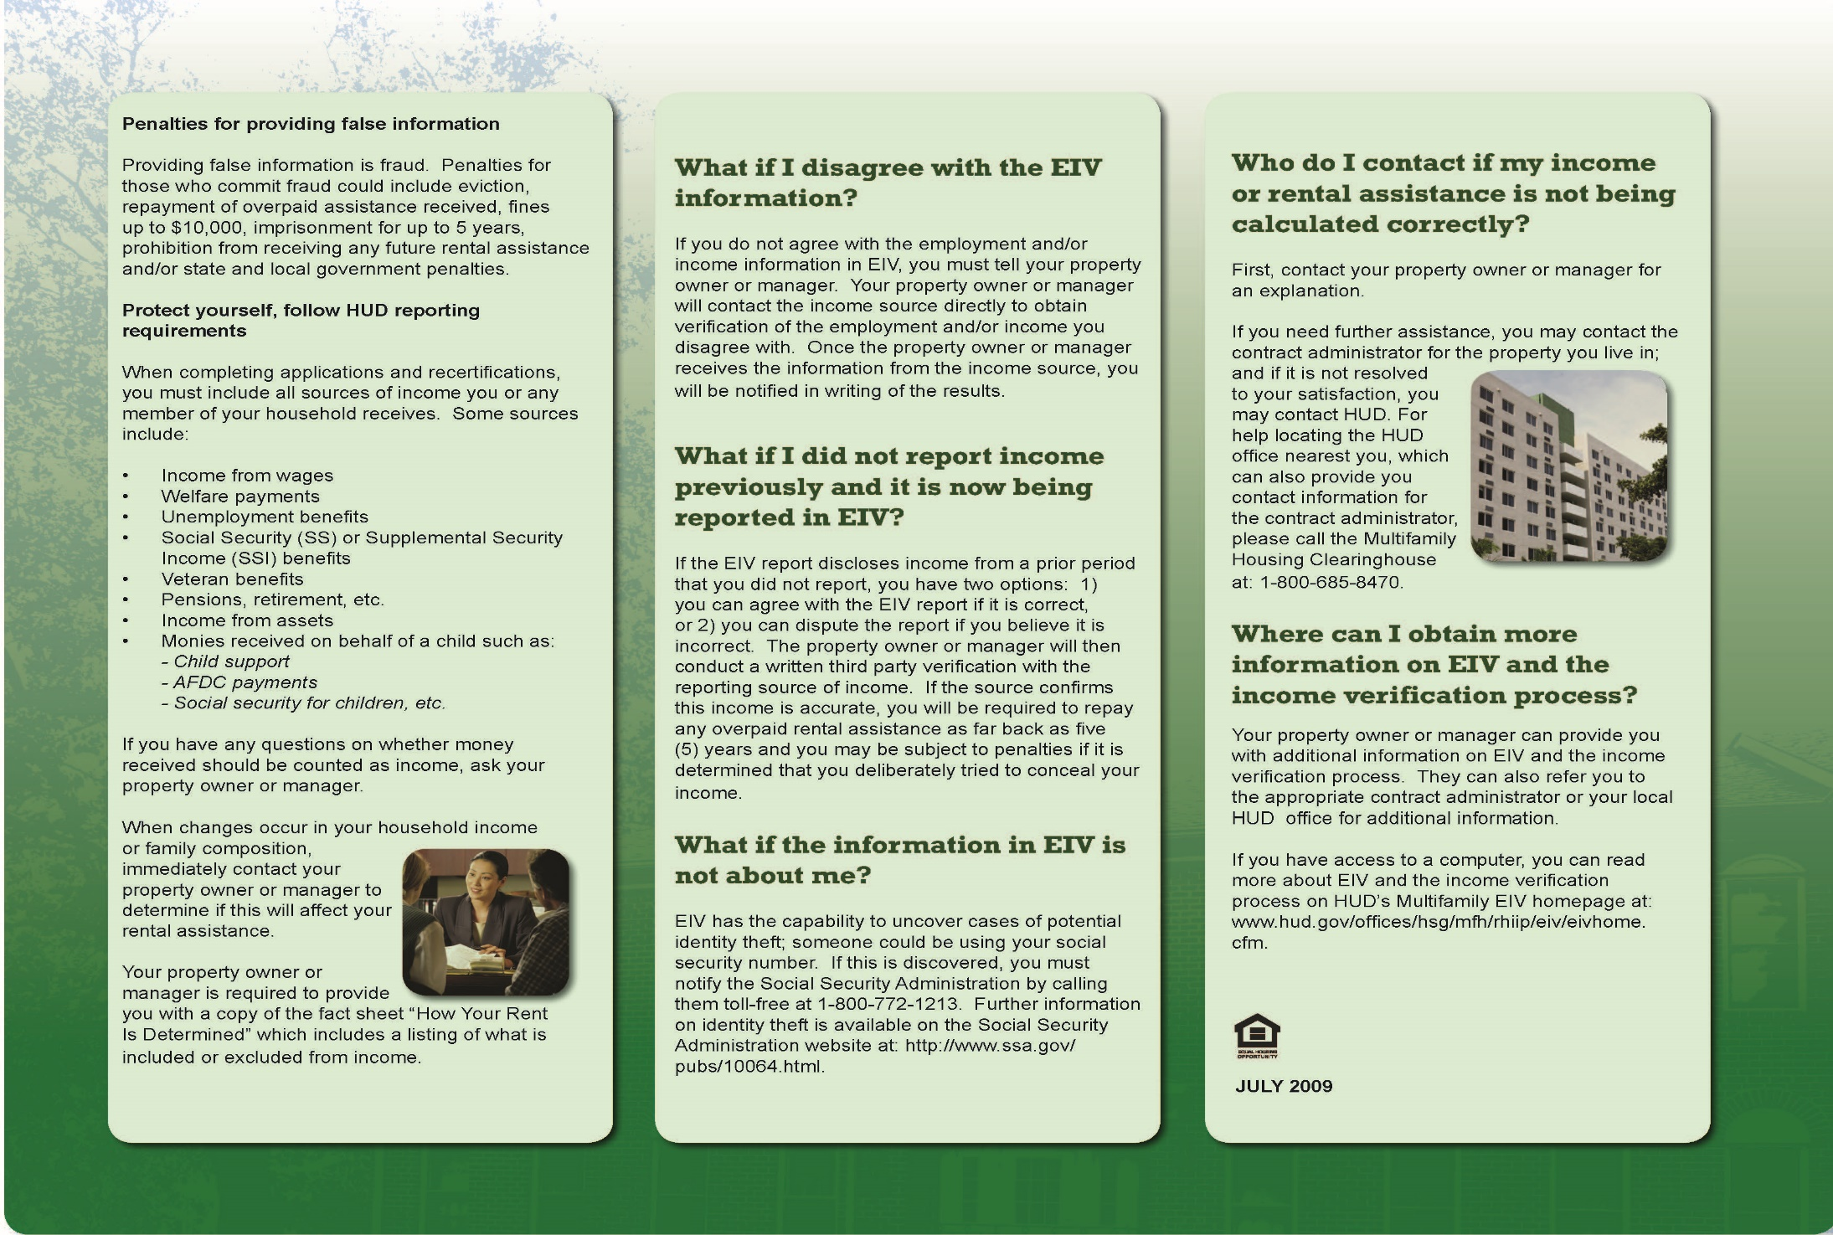
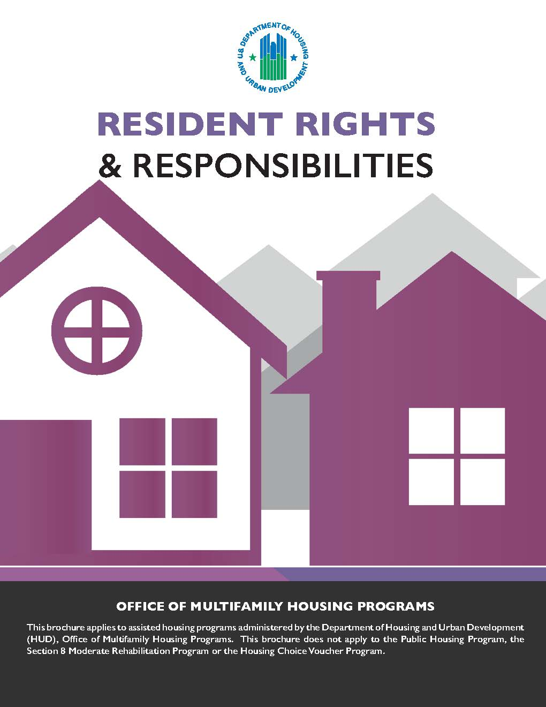
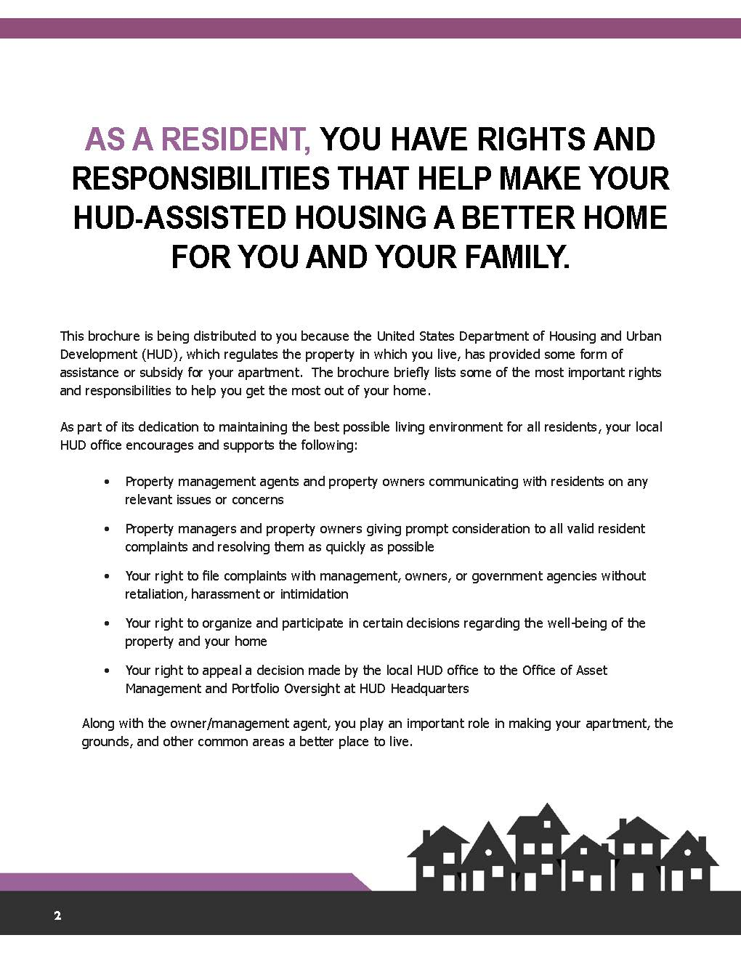
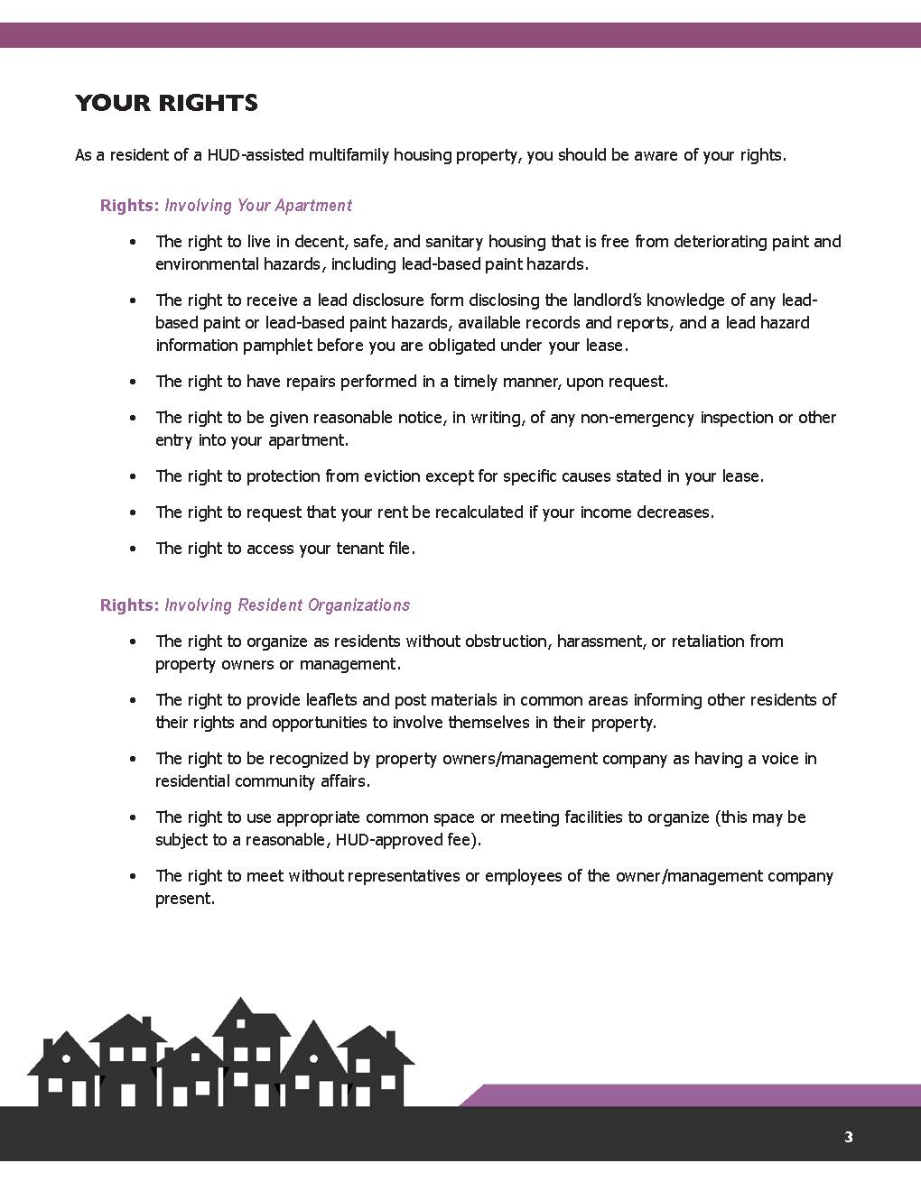
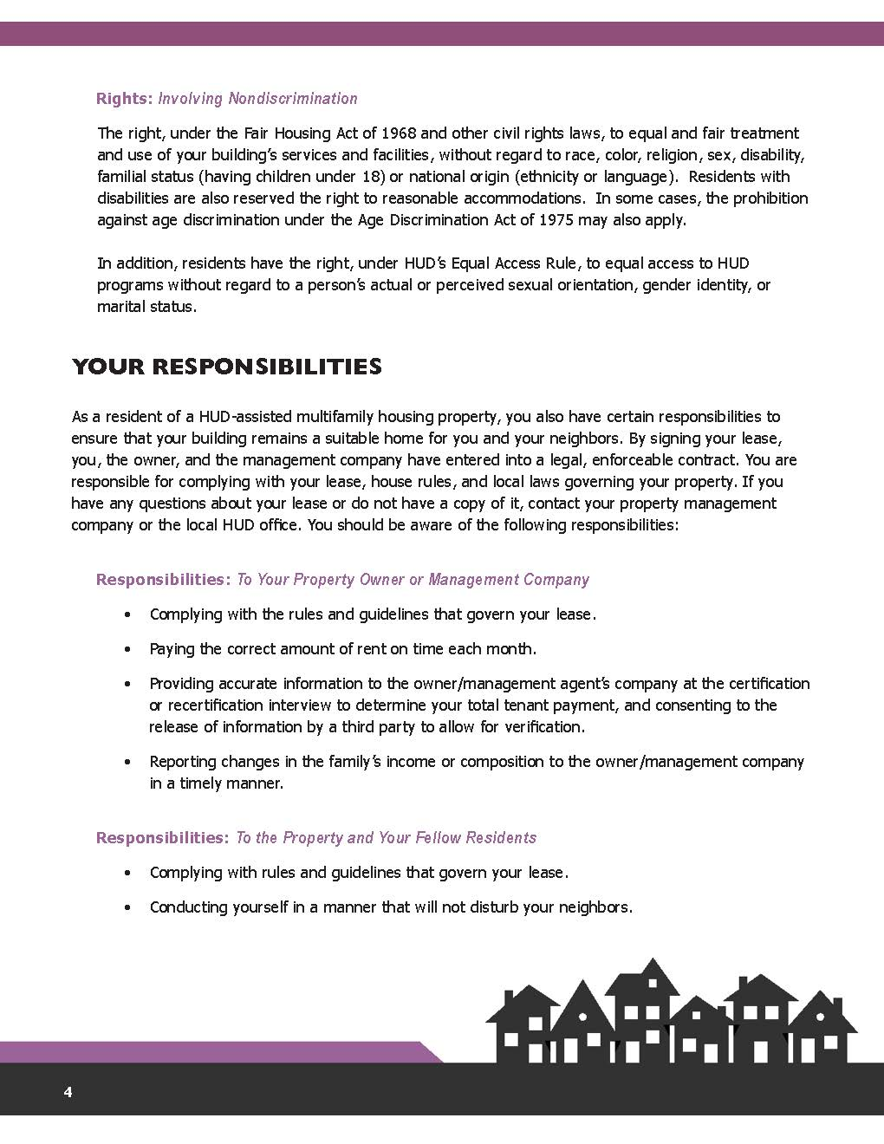
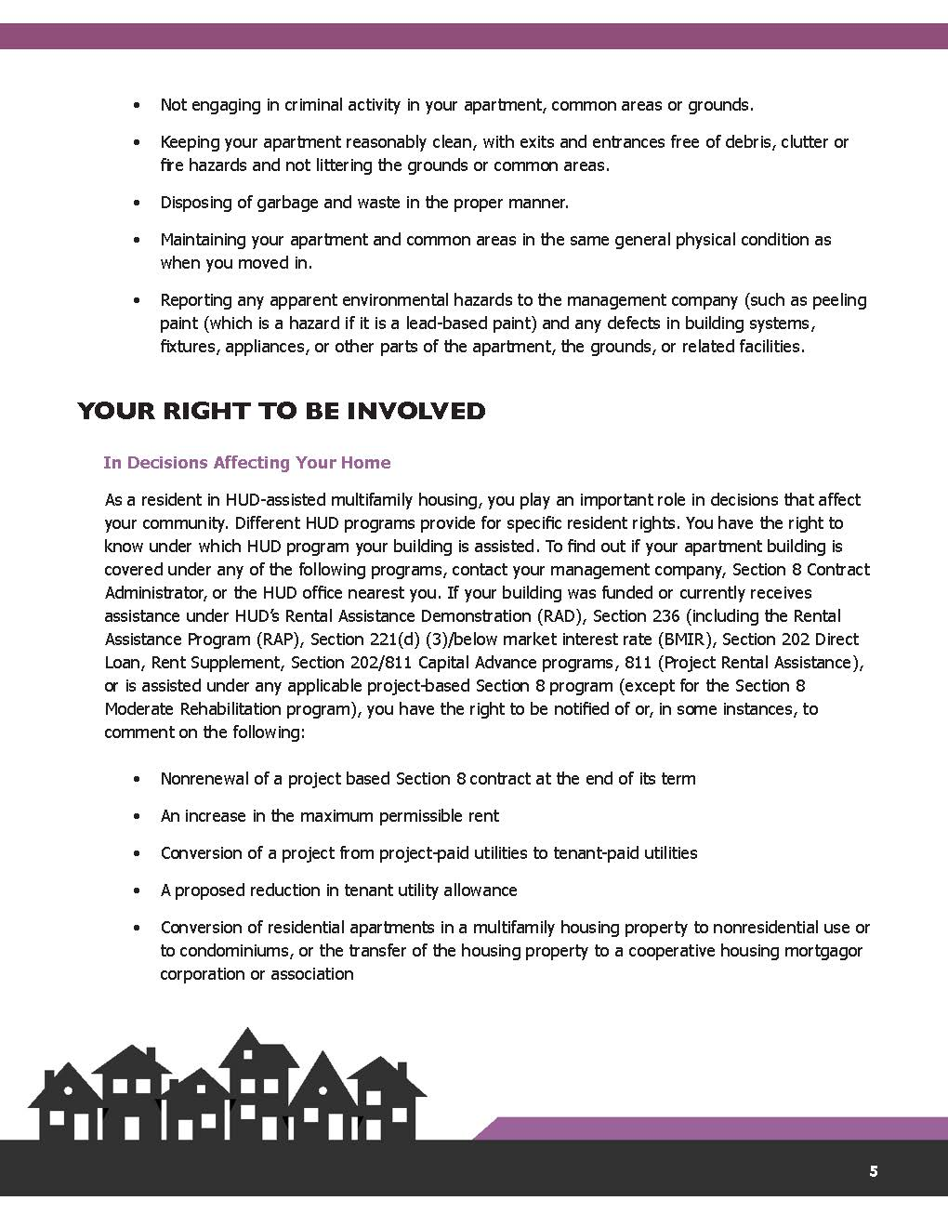
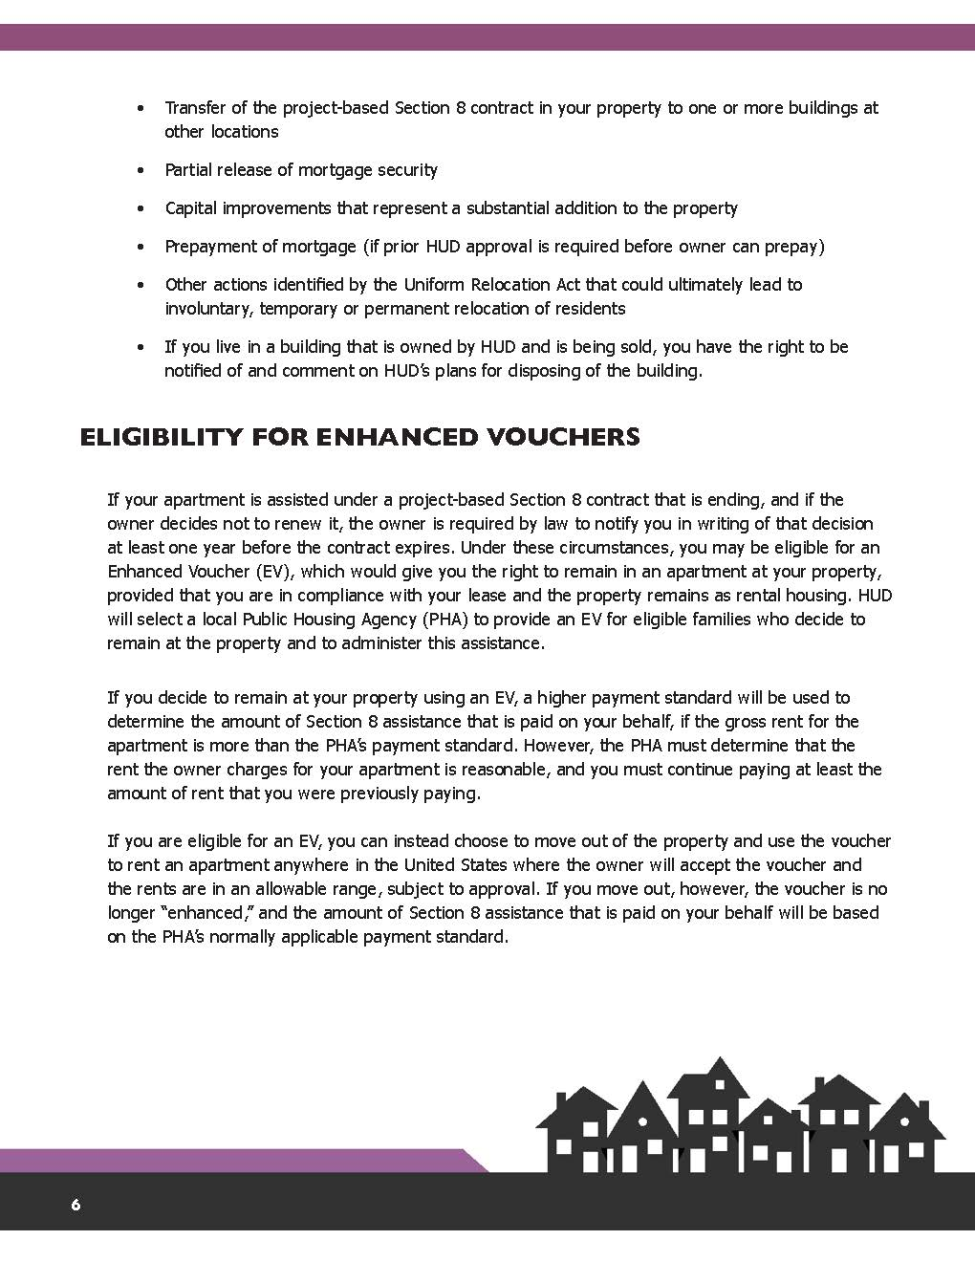
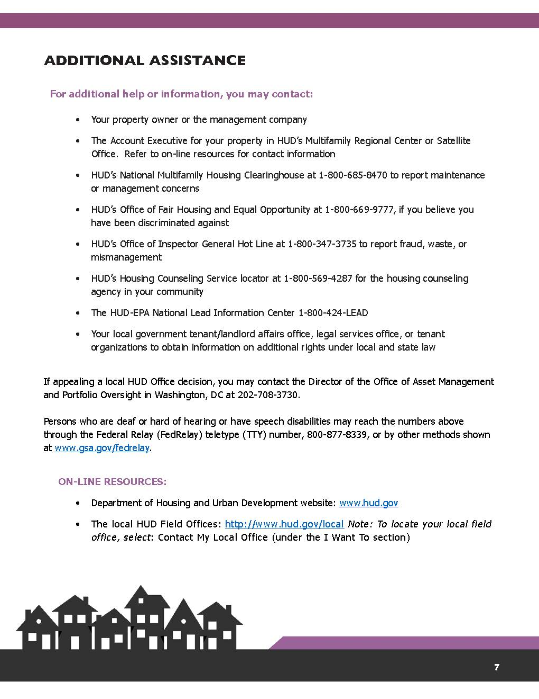
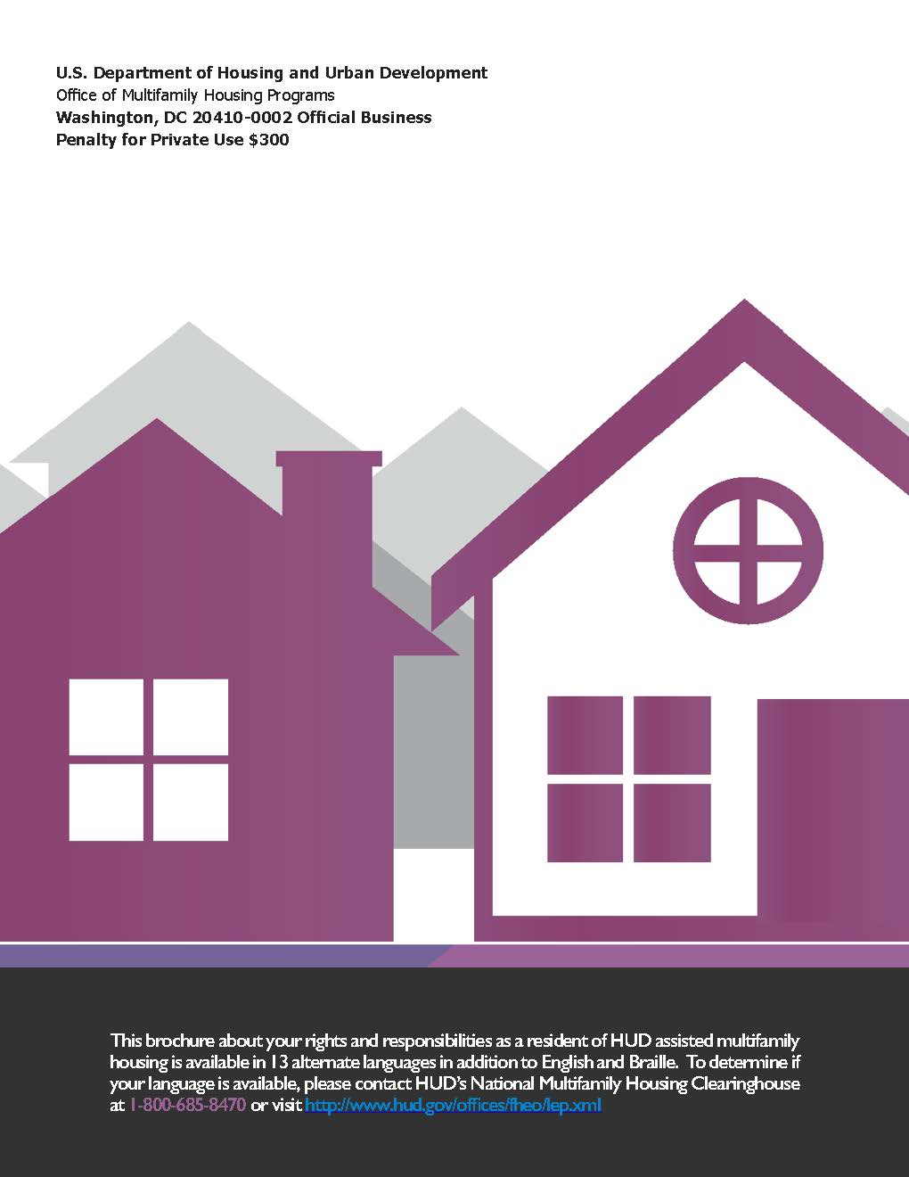
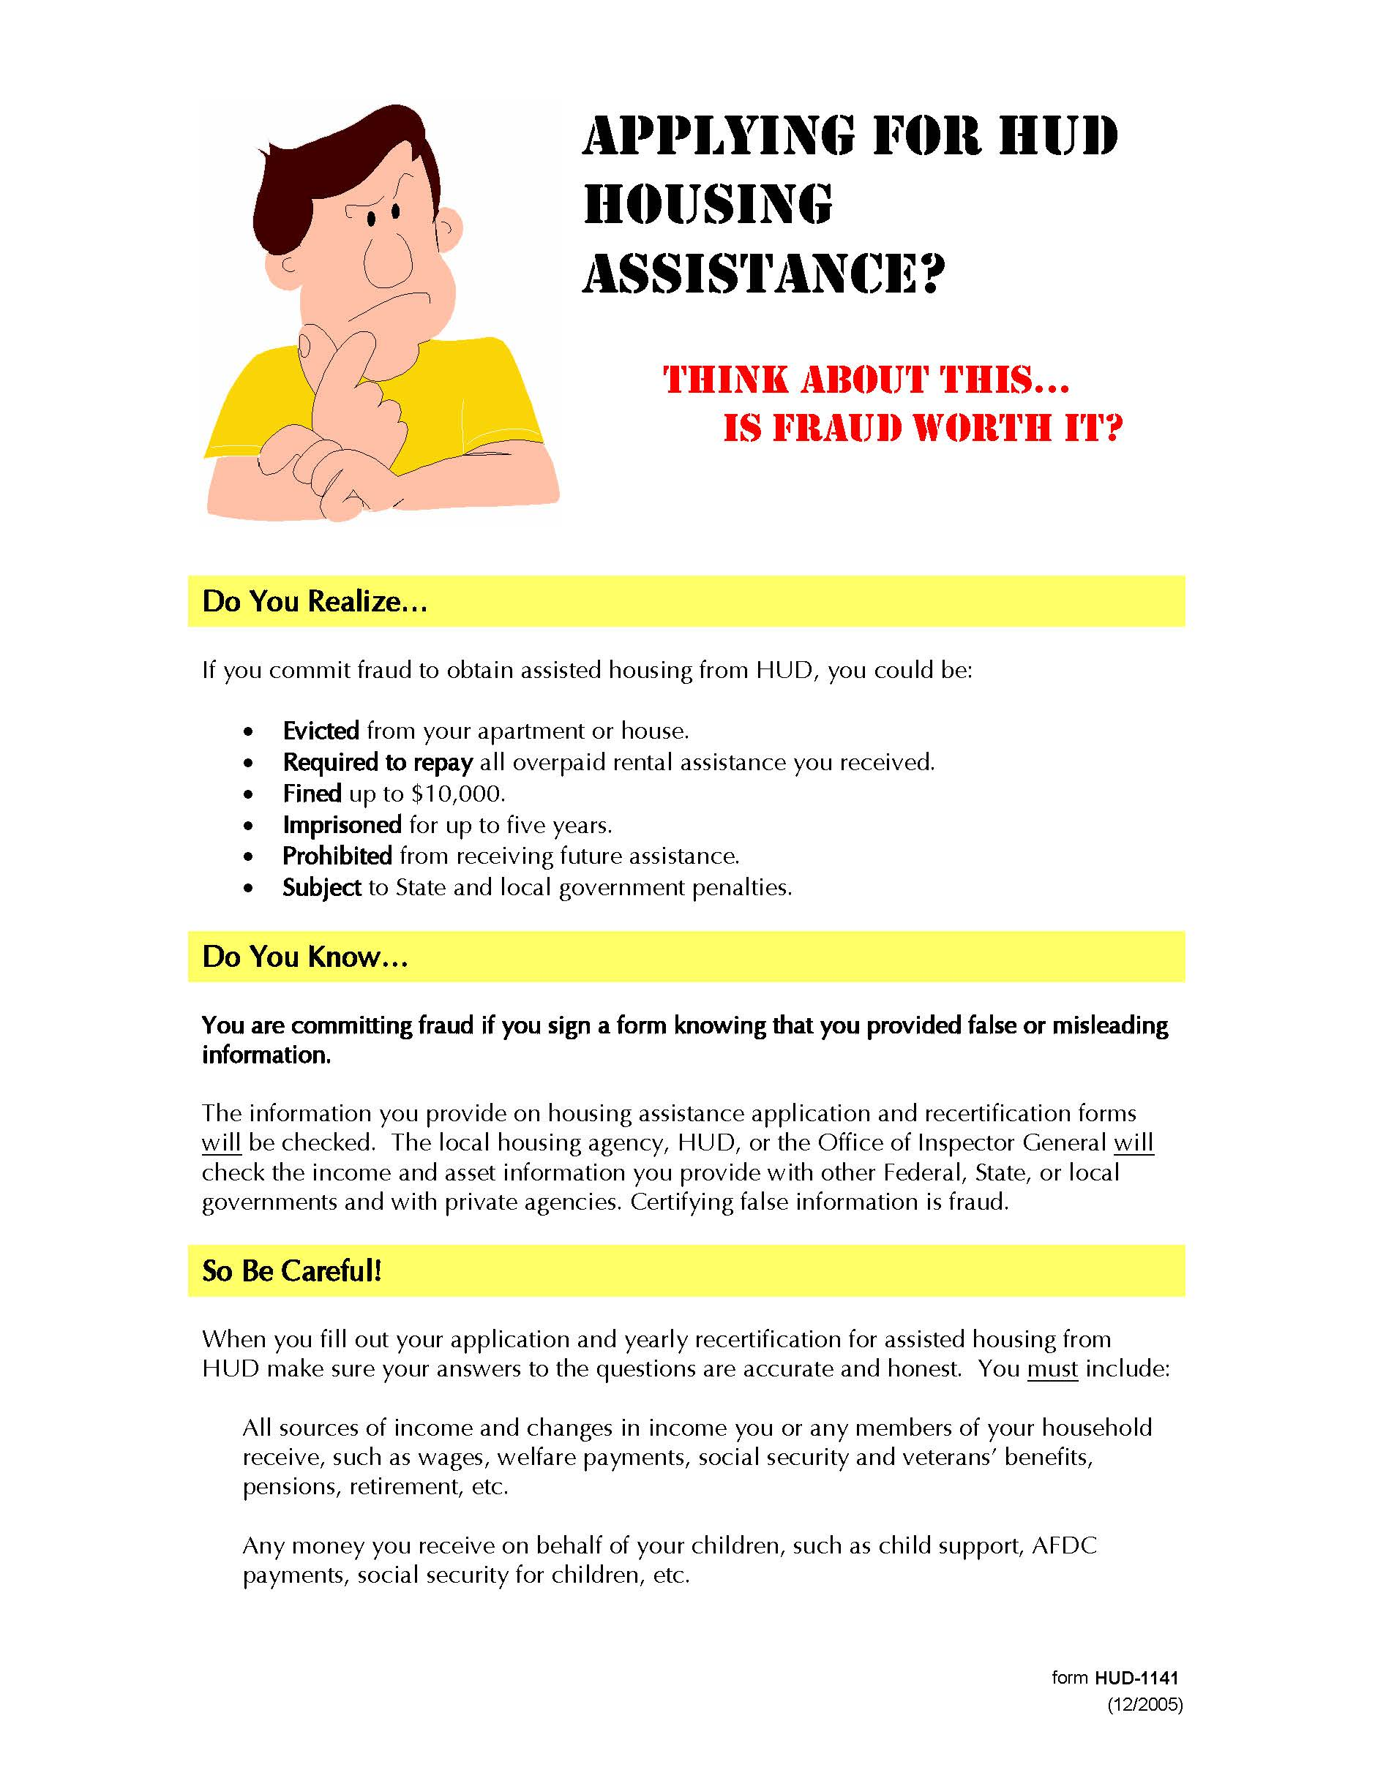
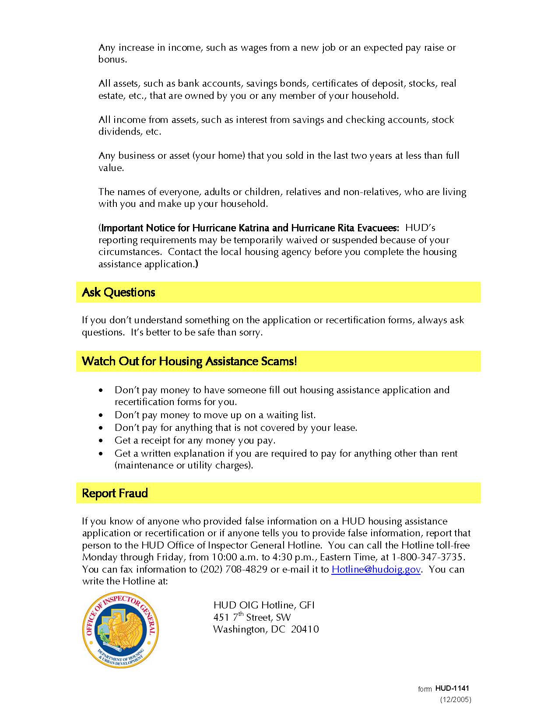

Acknowledgement of Receipt of Required Documents

The Acknowledgement of receipt of required documents is also available on our web site at XXXXX@XXX.com.

This form must be completed by the Head-of-household only.

We are required to provide you with certain documents that provide information about your rights, responsibilities and protections. All household members should review these documents. If you have any questions, please contact the property management staff.

This acknowledgement allows us to document your file and show that you were provided with these documents and allowed to ask questions. (Note from RBD – not required by HUD at application – required to provide as part of the application process before MI. You must choose if you want to include with your application package.)

Print HOH Name____________________________ Certification Type: Annual Recertification

(Note from RBD – edit this document as appropriate. Delete comments in green)
Document Name
9887 Fact Sheet– signed copy of the 9887/9887A must be in the applicant/resident file (not required by HUD at application but required at move-in) https://www.hud.gov/sites/documents/9887.PDF
EIV and You Brochure (required when applicant is at top of waiting list and at each AR) https://www.hud.gov/sites/documents/DOC_20470.PDF
HUD Fact Sheet (How Your Rent is Determined) (required at MI and AR) https://www.hud.gov/sites/documents/DOC_14955.PDF
Resident Rights & Responsibilities (required at MI and AR) https://www.hud.gov/sites/documents/DOC_12162.PDF
Is Fraud Worth It HUD Form 1141 (optional but strongly recommended) https://www.hud.gov/sites/documents/1141.pdf
Lead-based Paint Brochure (required for properties built before 1978 housing children under 6 see HH 4350.3 Paragraph 6-8) https://www.epa.gov/sites/production/files/2017-06/documents/pyf_color_landscape_format_2017_508.pdf
LIHTC Documents (if you must provide other document under the state LIHTC requirements – add those documents here. Please note, this is not for documents that must be executed but rather documents provided for tenant review.)
Any State Required Documents (if you must provide other document under the state requirements – add those documents here. Please note, this is not for documents that must be executed but rather documents provided for tenant review.)

If you are disabled and would like to request an accommodation or if you have difficulty understanding English, please request our assistance and we will ensure that you are provided with meaningful access based on your individual needs.

Si usted está incapacitado y desea solicitar un acomodo razonable o si tiene dificultad para entender Inglés, por favor solicite nuestra asistencia y nos aseguraremos de que se le proporciona un acceso significativo basado en sus necesidades individuales. (Note from RBD – this Spanish translation was provided by a Microsoft translator tool. Be sure to verify with someone who speaks Spanish. If Spanish is not the alternative language described in your Language Assistance Plan, change this to comply with your LAP or add other languages.)

By signing this form, I acknowledge that I have received all of the forms and/or documents indicated above. I have been given the opportunity to ask questions the information provided in each of these forms.

________________________________________ __________________________
Signature (HOH) Date

